Iniciar novo modulo em App.js

angular.module(**'starter.filters'**, []);

**var *starter*** = **angular**.module(**'starter'**, [**'ionic'**, **'starter.controllers'**, **'starter.services'**, **'starter.filters'**,  
 **'angular-oauth2'**, **'ngCordova'**]);

Criar diretório de filters

E criar o filter joins

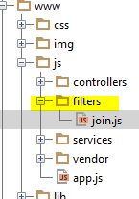

Chamar na index

*<!--FILTERS -->*<**script src="js/filters/join.js"**></**script**>

Filters join.js

**angular**.module(**'starter.filters'**).**filter**(**'join'**, **function**() {  
 **return function** (input, joinStr) {  
 *//transformar o array em string* **return** input.join(joinStr);  
 };  
});

Chamar ele na view

<**p**>{{o.product_names | limitTo:2 | join: ', ' }}</**p**>